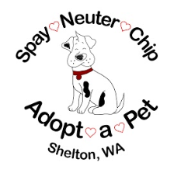
Adopt-a-Pet
Established: 1979 Celebrating 41yrs Strong
940 E. Jensen Rd
Shelton, WA 98584
Phone: 360.432.3091
Email: thedoghouse3091@hotmail.com

Bequest/Memorial/Honorarium Donation
Celebrate your life or the life of a beloved person or pet with a bequest/memorial/honorarium gift to Adopt-a-Pet of Mason County in Shelton, WA. When you donate in remembrance, your gift supports the actions of rescuing and rehoming the many dogs in need.
Please consider a Bequest donation the next time you are planning your estate.
If you would like to make a Memorial or Honorarium donation please complete the following form and mail your check to: Adopt-a Pet, 940 E Jensen Road, Shelton, WA 98584. Please make checks payable to: Adopt-a-Pet. An acknowledgement of your gift will be sent to the person you list. No dollar amounts will be disclosed.

---------------------------------------------------------------------------------------------------------------------

I would like to give a Memorial/Honor gift to Adopt-a-Pet in the amount of $__________
My Name: _____________________________________________________________
Address: ______________________________________________________________
Street City State Zip Code
Phone Number: _____________________ Email: _____________________________

Memorial - in memory of: ___________________________________________
Honor - in honor of: _______________________________________________

The name and address of the person to receive the acknowledgement card:
Name: _______________________________________________________________
Address: _____________________________________________________________
Street City State Zip Code

